PROJECT DEVELOPMENT PHASE DELIVERY OF SPRINT 4

|  |  |
| --- | --- |
| DATE | 17.11.2022 |
| TEAM ID | PNT2022TMID34348 |
| Title | Project - Retail Store Stock Inventory Analytics |

1.YEARLY SALES AND REVENUE

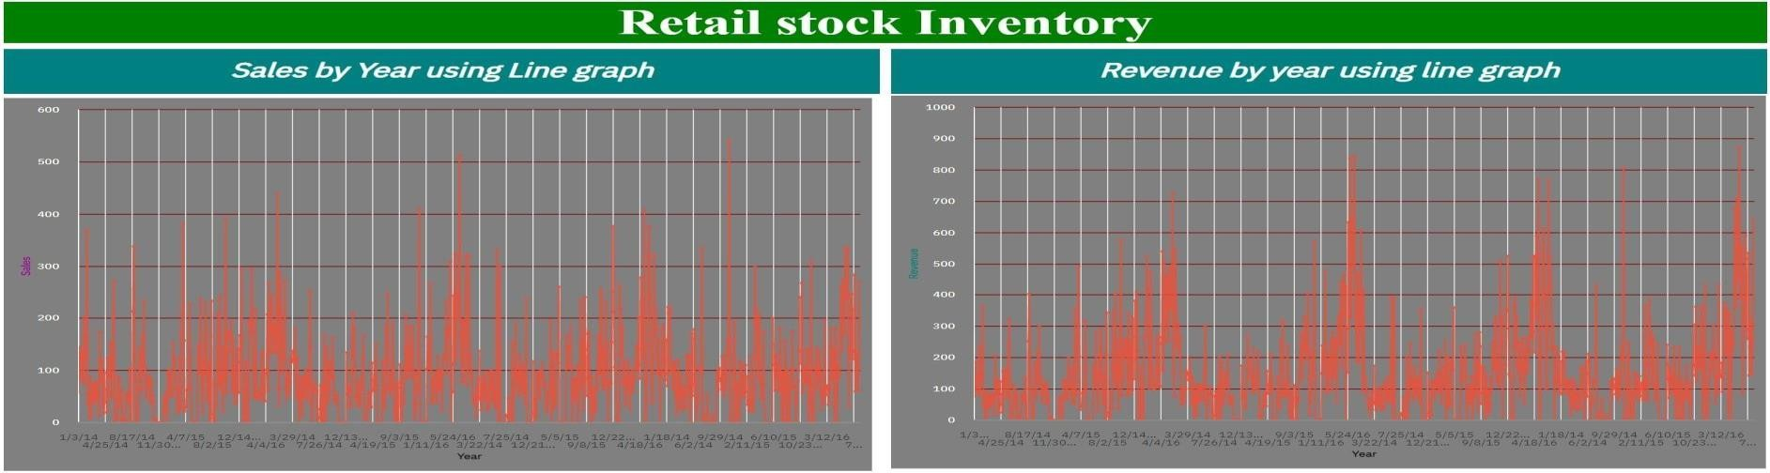

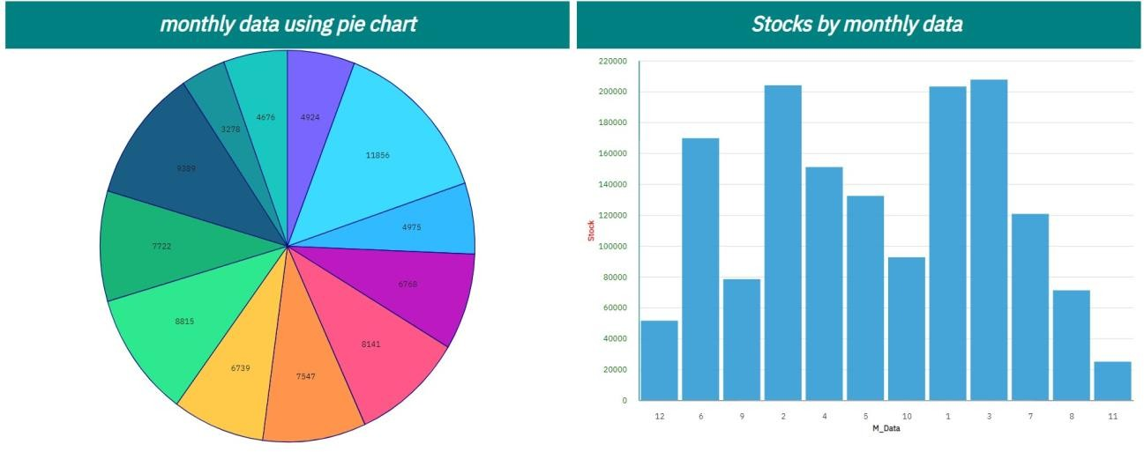

3.MONTHLY WISE REVENUE, STOCKS

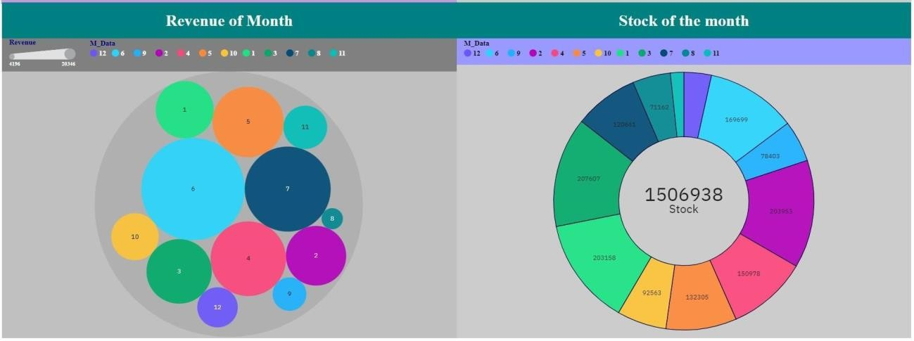

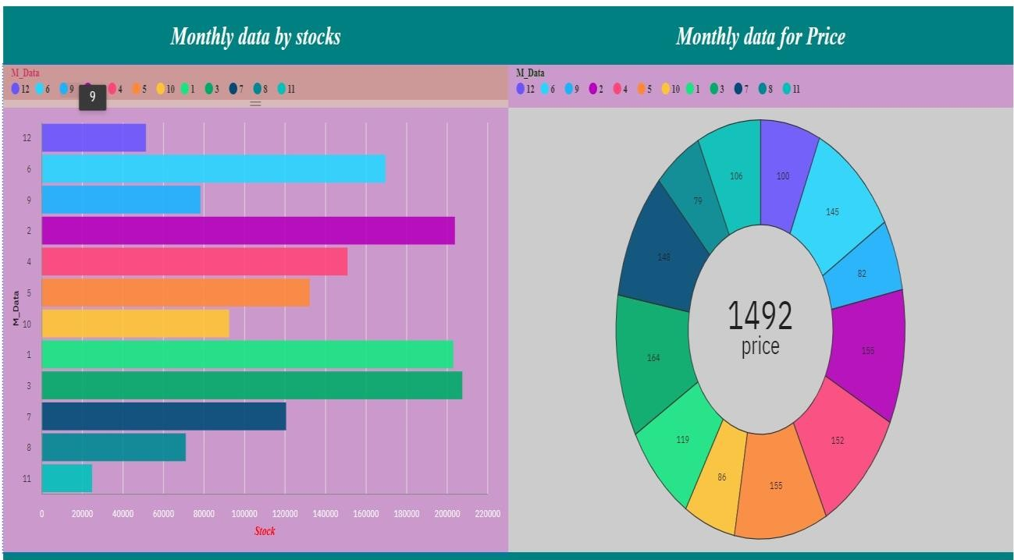

1. **MONTHLY DATA, STOCKS, SALES**

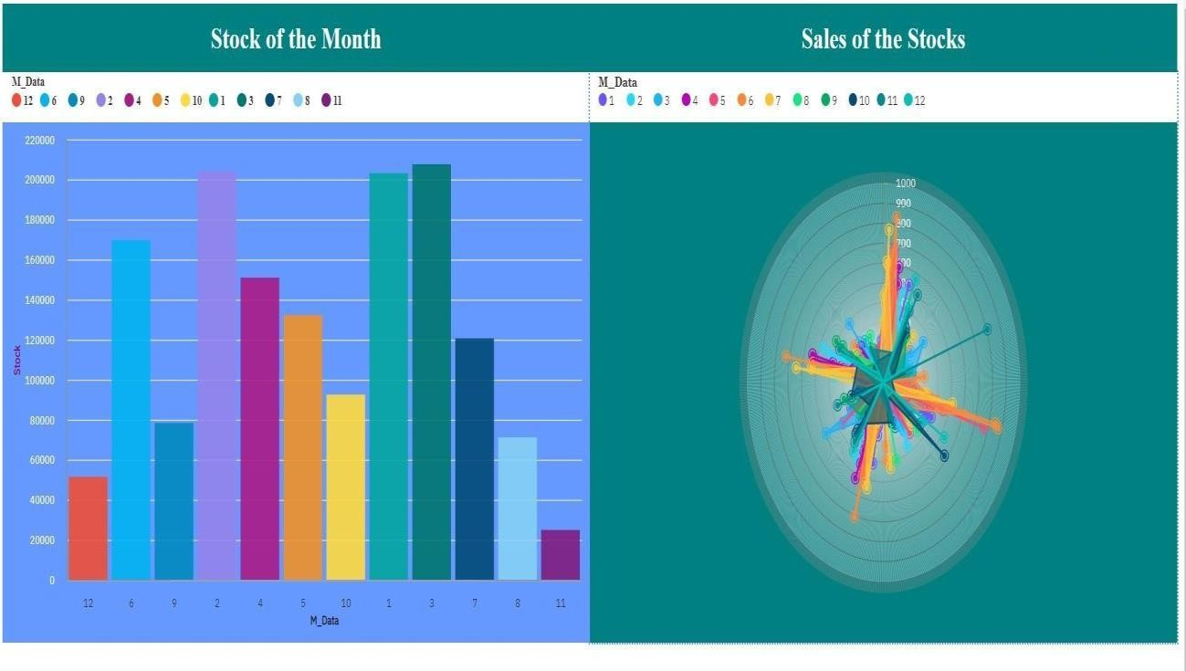

* + https://us1.ca.analytics.ibm.com/bi/?pathRef=.my_fol ders%2 FSPRINT 4R&action=edit
  + https://us1.ca.analytics.ibm.com/bi/?pathRef=.my_fol ders%2FS PRINT4R&action=edit